Name
Course
Date
Financial Management
QUESTION 1
- .Use “PMI” function of spreadsheet to calculate montly payment on the basic of 20 years ( 240 months) a mortization period.
Put values and formulae in the spreadsheet as shown in the image below:
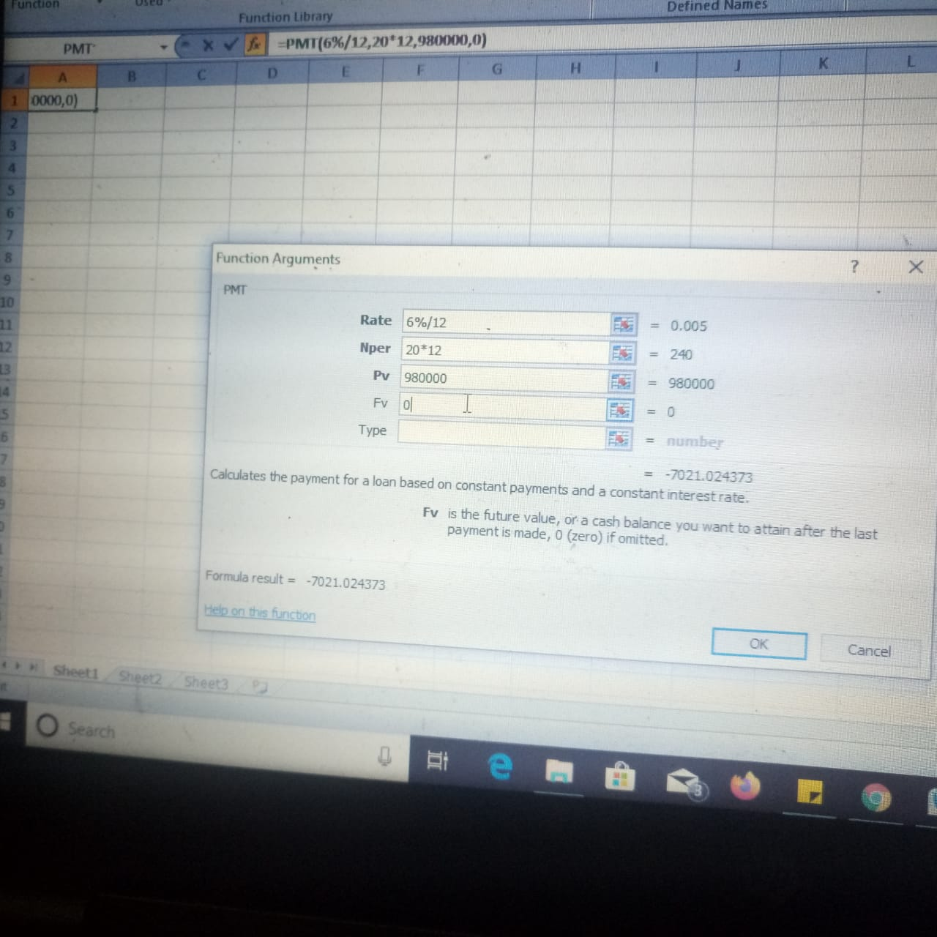
The obtained results after putting the values and “PMT” Function in spreadsheet will be the following:
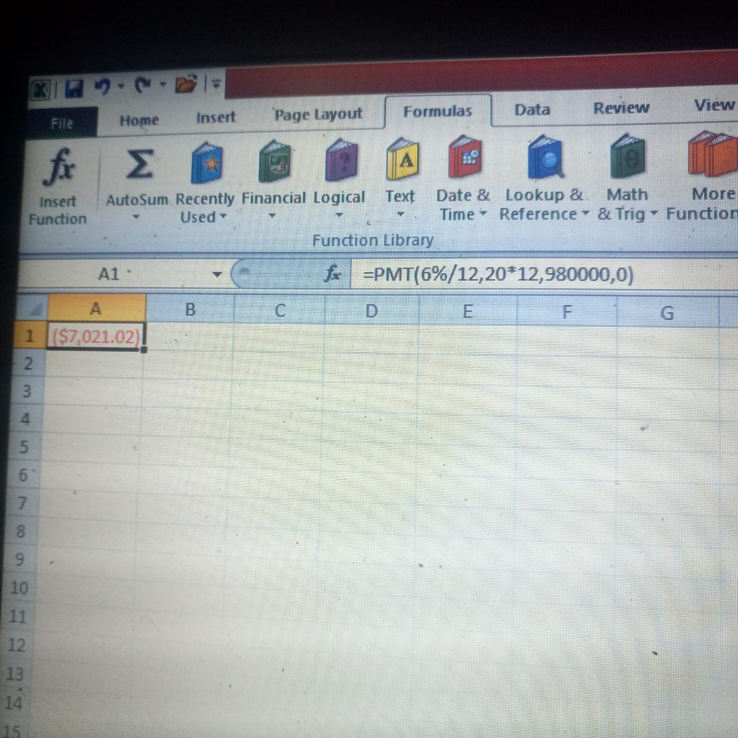
Thus Initial monthly payment on his Mortgage is $ 7021.02
- Use “PV” function of spread sheet to calculate loan balance after 5 years,here the amortization period will reduce by 60 months.
Put Values and formulae in spreadsheet as shown in Image below:
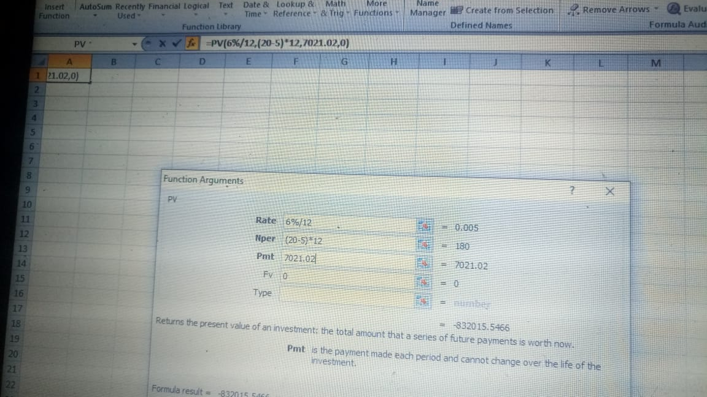

The obtained results after putting the values and “PV” function in spreadsheet will be the following:
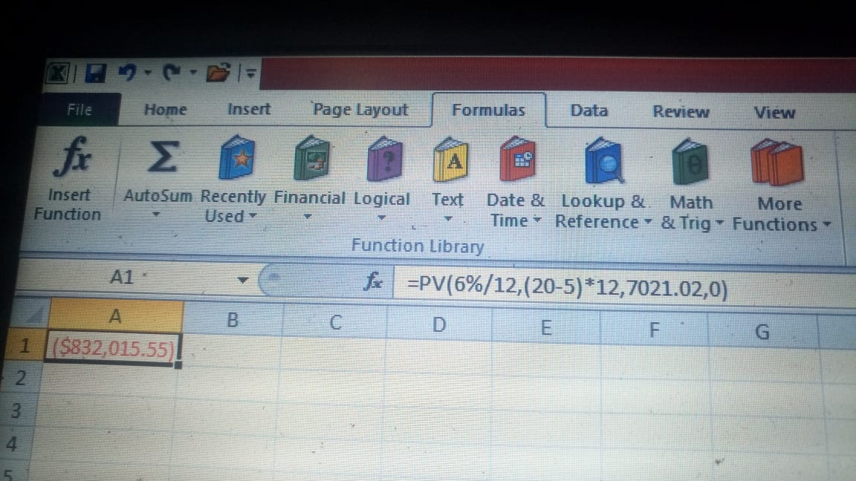
Thus, the outstanding principal on his Mortgage is : $ 832,015.55
- Use “PMT” Function of spreadsheet to calculate monthly payment on the basis of 15 years (180 months) a mortization period.
Put values and formulae in spreadsheet as shown in the image below:
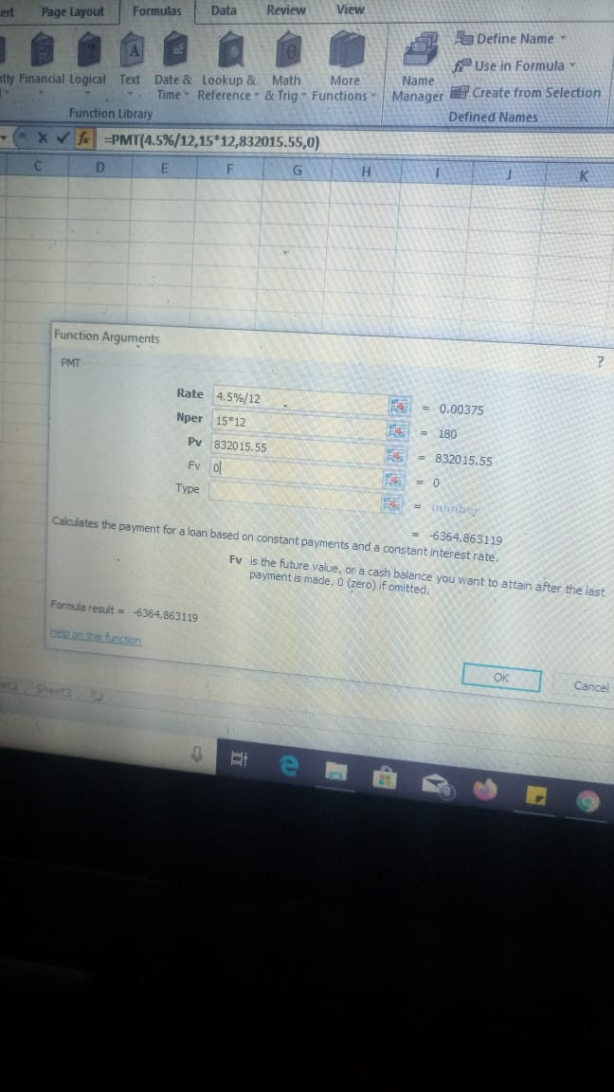
The obtained results after the values and “PMT” Function in spreadsheet will be the following:
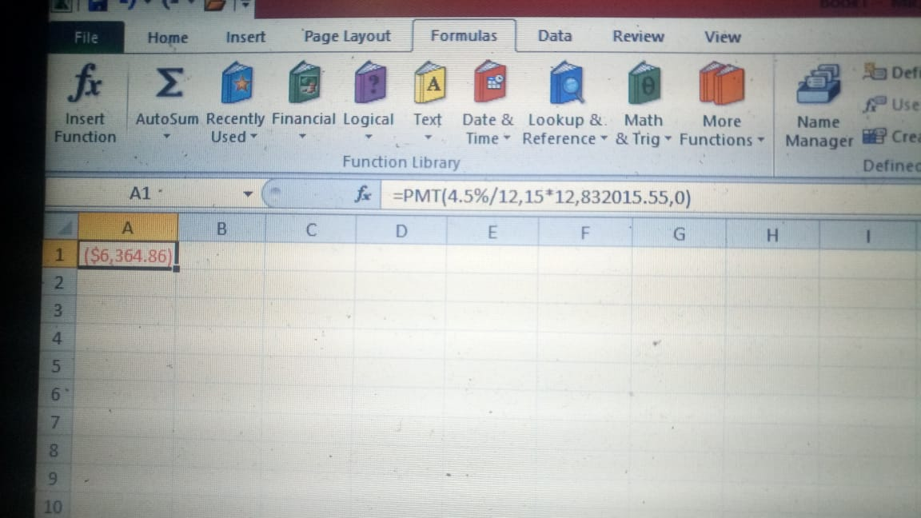

Thus, monthly payment on new rate of interest is: $6364.86

QUESTION 2
In order to calculate how much will Jennifer have after 3 years,
we will first calculate the future value of $5,000 after 3 years
P(1+r/n)^{n*t}
where P = Principal amount, r= rate of interest, n= number of installments, t= number of years
5000*(1+ 0.015/12)^{12*3}
=$5000(1.00125)³⁶
=$5000*1.046
=$5,229.99
Now we will calculate future value of the payments
d*[(1+i)^{n*t} -1/i *(1+i),
where d = monthly deposit, i = rate/number of instalments in a year
$500*[(1+0.00125)³⁶-1/0.00125*(1+.00125)]
$500*(1.046-1)/0.00125*1.00125
18,423
The total value Jennifer will have after 3 years is the total of $5,229.99+ $18,423
$ 23,652.99

QUESTION 3
SOLUTION:
The KJ Corporation has averaged an ROE of |  |  |  |  |  |  | 14% | over
the past 5 years and that should continue into the
future. The firm has a payout ratio of |  |  |  |  |  |  | 67% | on
earnings per share of |  |  |  | $3.94 | and paid the dividend
yesterday. The discount rate for a firm of KJ's
risk level is |  |  | 15%
a) | What is the expected Growth Rate of KJ's dividend?
b) | What is KJ's current stock price?

a) Dividend growth rate = ROE*(1-dividend payout ratio)
ROE = |  | 14%
Payout ratio = |  | 67%
Dividend growth rate = 14%*(1-67%)
 |  | 4.62%
b) we can use the dividend discount model to compute the share price
price = expected dividend/(required rate - growth rate)
Expected dividend = |  |  | =3.94*67%*104.62%
 |  |  | 2.76
price = 2.76/(15%-4.62%)
 |  |  | 61.74

QUESTION 4
SOLUTION.
YTM on the bond= 240 basis points above YTM of similar govt. bond
One basis point = 0.01%
so, 250 basis points= 240*0.01%= 0.024 or 2.4%
So, YTM on JG's bond = 2.4%+2.4%= 4.8%
Coupon rate should JG choose if it wants the bonds to sell at par= 4.8%
as when Price=Par, Coupon Rate= YTM= 4.8%
b. $ Amt. of capital they will raise from the sale=
1500*$ 1000=
1500000
c.2 years later--
YTM=2.8%+2.4%=5.2%
Price of the bond=(Copuon pmt.*(1-(1+r)^-n)/r)+(FV/(1+r)^n)
ie. ((1000*4.8%)*(1-1.05^-8)/0.05))+(1000/1.05^8)=
((1000*4.8%)*(1-1.05^-8)/0.05))+(1000/1.05^8)
987.074
d..JG's bonds now sell at a
PREMIUM
YTM< Coupon Rate
Price> Par

QUESTION 5
?

QUESTION 6
A= P( 1+ r/12)¹²
Substitute the Value in the formula:
A= $ 1670 ( 1+ $\frac{3}{12}/100)$^{12X1}
A= 1670(1+0.0025)¹²
A= 1670(1.0025)¹²
A= 1720.80
The is the amount that has already been accumulated.
Now we need to find out for the remaining amount how many months will be needed.
The remaining amount is:
=$5000- $1720.80
=$3279.20
This will be the amount and we will calculate the principal amount needed for accumulating this amount.
Substitute the Values in the formula;
$3279.20= P { 1+ (3/12)/100}^{12X1}
$ 3279.20= P{ 1+0.0025}¹²
$ 3279.20= P(1.0025)¹²
$ 3279.20=P(1.0304)
P=3279.20/(1.0304)
P= $ 3182.45
The principal amount needed is $ 3182.45.
The number of months needed is:
3182.45/144
22.100 or 23 months approximately
The time needed will be 23 months or 1 year 11 months

